# Unit 3 – Lesson 10. The Math Behind Navigation Mesh Part 1.

# – The Art Gallery Theorem and Polygon Ear Theorems

**Aim:**

What are the math theorems behind the game mesh and mesh navigation?

**Objectives:** After the lesson, students should be able to understand:

* Triangularization of polygons
* Art Gallery Theorem
* Polygon Ear Theorems

**CLASS PROCEDURE:**

***Do Now:*** You are the owner of two art galleries. The first gallery has the shape of a triangle, and the second gallery has the shape of a non-convex polygon (as shown in the figure above). You want to place guards at the vertices of each gallery such that the whole gallery will be thief proof.

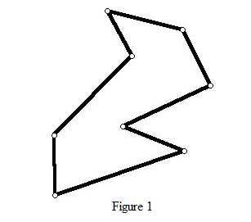

1) Where will you place the guards in a way that the whole gallery is guarded?  
2) How many guards do you have to hire?  
3) What is the minimum number of guards as required to protect your expensive art collection?

***Class Discussion / Presentation:***

1. Take a look at the first gallery. If the gallery has a shape of a triangle, we only need one guard to watch the gallery. The guard can be placed at any vertex of the triangle.
2. If the gallery has a shape of a non-convex polygon, it’s harder to find the number of the guards. *But, if we can divide the polygon into non-overlapping triangles, and place a camera at each one of those triangles, then we can make sure that the whole gallery is guarded!*

In the “Do Now”, the polygon in Figure 1 can be divided into triangles as shown in the diagram below.

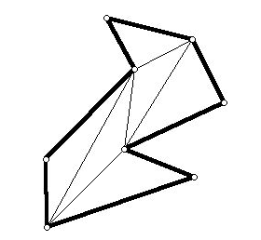 Question for the students:

Can any polygon be divided into non-overlapping triangles? And how do you prove that?

The answer is yes. To prove this we need to know the Ear Theorem.

1. Ear Theorems and Proofs
2. What is a **polygonal ear**?

We say that a Polygon P has an ear at vertex V if the triangle formed by V and its two adjacent vertices lies inside P, and there are no vertices of P inside the triangle formed by V and its 2 adjacent vertices.

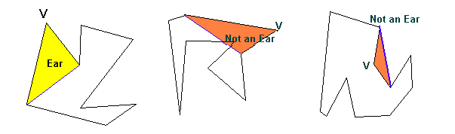

1. **Ear Theorem: Any simple polygon has two ears.**

This theorem can be proved by induction on the number of vertices of P.

Small Group Activity 1: Discuss how to prove the Ear Theorem by induction.

Divide the students into groups of four, and give the students 10 minutes to discuss how to prove the Ear Theorem by induction.

***Proof of the Ear Theorem:***

Induction hypothesis: Any simple polygon with less than n vertices has 2 ears.

Base Case: If n = 4

It’s a quadrilateral.

This quadrilateral can be split into 2 triangles that will be the 2 ears of P.

*Induction Step:*

P is a polygon with n vertices.

Let V be a concave vertex of P (This eliminates the case where the triangle is outside P).

Let v1 and v2 be its two neighboring vertices.

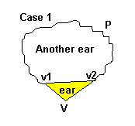Logically there are two cases to consider – either there is an ear a t V or there is none.

*Case 1: There is an ear at V.*

Remove this ear from P adding edge (v1,v2) to the remaining set of edges, and we obtain another simple polygon.

This polygon has n-1 vertices so it must have two ears except if it is a triangle in which case it has one. (From induction hypothesis) It follows that the P had 2 ears.

*Case 2: There is no ear at V.*

This means there is *at least* one vertex in the triangle v1,V,v2.

Glide a line parallel to v1,v2 start from v1 until it reaches the last vertex before V. Call this vertex z.

Since there are no points closer to V than z, the segment Vz must lie inside P.

Vz divides P into 2 polygons, say P_left and P_right where P_left is the part of the polygon that was on the left of Vz with edge Vz added, and P_right the other part, also with the new edge Vz.

P_left and P_right both have less then n vertices so they both have two ears (Induction hypothesis).

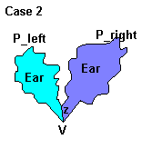

The problem now is to show that this implies P has 2 ears.

It could be that one of P_right and P_left is a triangle. Say it was P_right. Then P_right is an ear of P and P_left must have 2 ears. Surely one of them is not at V or Z. This ear is the second ear of P and P has 2 ears.

It could also be that neither of P_right and P_left is a triangle. And in that case by the same reasoning as above, each of P_rigth and P_left must have at least one ear not at either V or Z. These 2 ears are then the 2 ears of P.

**End of Proof.** (*The proof strategy is that of G.H.Meisters*)

1. **Theorem of Polygon Triangulations: Any simple polygon can be triangulated.**

Now we can prove that any simple polygon can be triangulated!

Small Group Activity 2: Discuss how to prove that any simple polygon can be triangulated. (Hint: It can be proved by construction!)

Divide the students into groups of four, and give the students 10 minutes to discuss how to prove the theorem by construction.

***Proof that any simple polygon can be triangulated: (by construction)***

As per the Ear Theorem, we can always find an ear in a simple polygon P.

This gives us a method to triangulate a polygon P.

Find a vertex V where there is an ear of P.

Remove V and add an edge between its nearest neighbors v1,v2. (note : Edge v1 v2 will be part of the triangulation of P.)

We now have a new Polygon Pnew.

Find an ear in Pnew, let’s say at vertex X and do the same as above, storing the neighboring vertices and removing X from Pnew.

Do this until we are left with a triangle.

The edges we will have stored are the diagonals that triangulate P.

**End of Proof.**

***Pair – sharing Activity:***

Continue working on the Maze game. Due: November 10th.